Name____________________________________________ Period_________ Date____________

Which Do Ewe Pick?

Directions: Livestock producers must decide which animals they keep in their breeding herd from year to year as the animal ages. They must also add to their herd to replace animals that have come to the end of their productive life. Read the following scenarios and choose which animals you will keep.

Scenario 1: Replacement Heifers on a commercial cattle ranch
- You would like to keep 2 of the following heifer calves to maintain and build the size of your cow/calf operation. Preferred replacement heifers come from an older cow because she is more likely to pass on good fertility traits. Dark pigmented eyes are also preferred to lessen disease. You don’t want to keep heifers that came from difficult births. Place an “X” on the heifers that will go to market.
Heifer A:

Solid red color from an 8 year old cow who has never had difficulty giving birth or feeding her calves.

Heifer D:

Solid black calf born to 6 year old cow who has delivered a calf each year without difficulty.
Heifer C:

Solid black calf born to first calf heifer. Slow growing due to low milk production of mother.
Heifer B:

Black baldie calf with white pigmented eyes. High birthweight required calf to be pulled at birth.
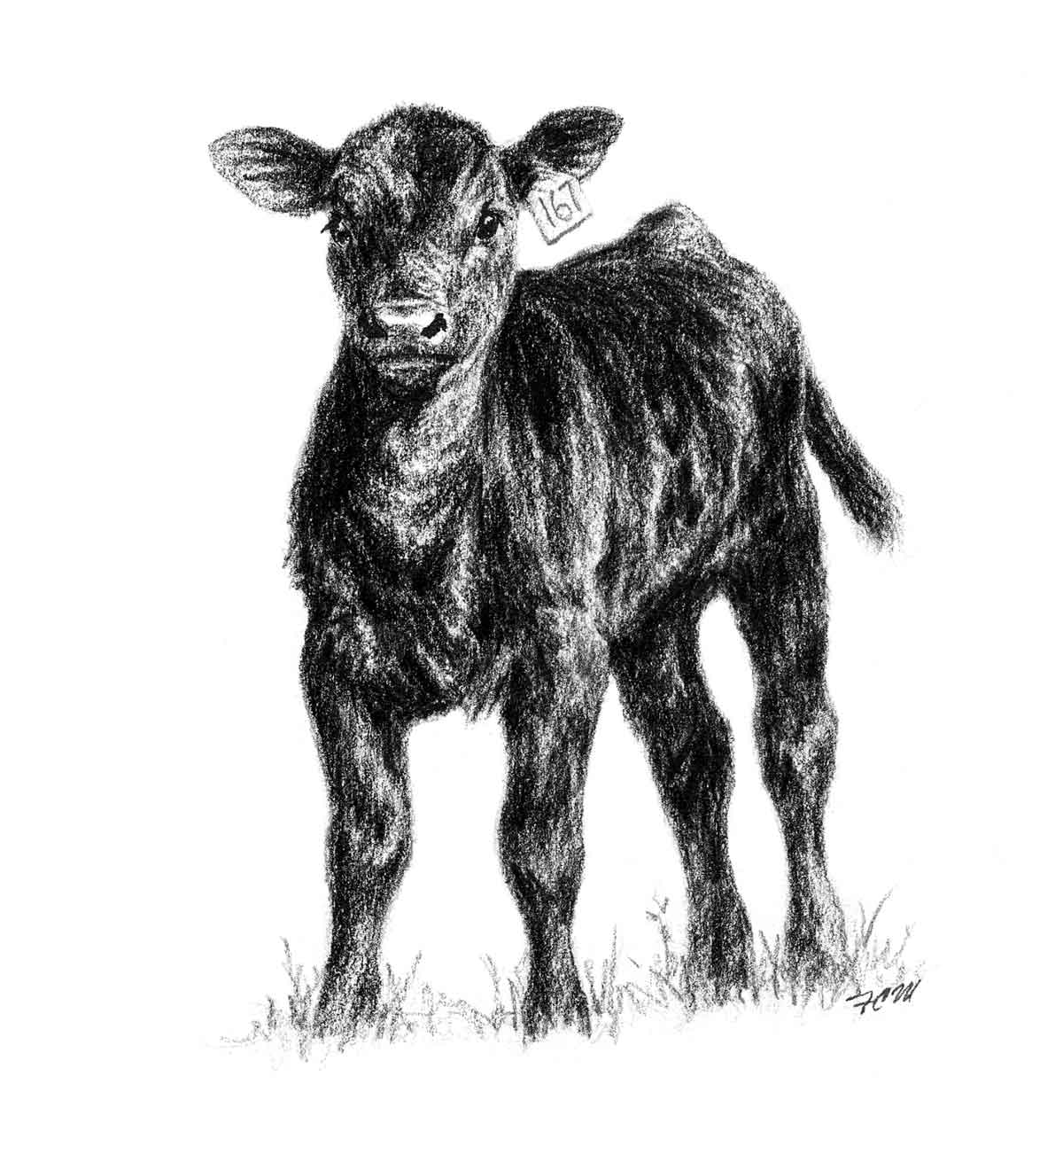

- Why?

Scenario 2: Replacement gilts on a commercial pig facility
- Choose 2 of the following gilts to keep for breeding on your pig farm. It’s very important for the gilt to have correct structure of her feet and legs to remain sound on the cement of most pig facilities. Gilts should have 12 well-spaced teats on her underline to be able to feed a large litter. They also consider the fertility statistics of the mother and prefer gilts that came from a large litter. Place an “X” on the gilts that will go to market.
Gilt E:

Correct feet and leg structure, 12 teats, came from litter of 14, but only 12 lived.
Gilt D:

Correct feet and leg structure, 12 teats, came from litter of 5.
Gilt C:

Slightly post legged and stiff in walking, 11 teats, came from litter of 13.
Gilt B:

Correct feet and leg structure, came from litter of 12, and has 12 teats.
Gilt A:

Correct in feet and legs, 9 teats, came from litter of 8.

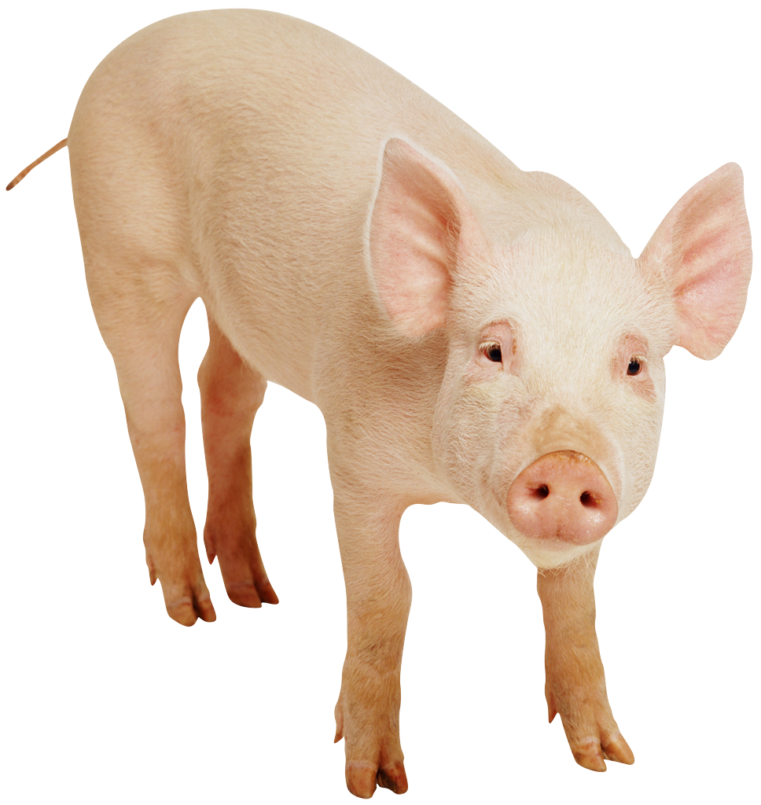

- Why?
Scenario 3: Replacement ewes on a commercial sheep farm
- You would like to keep 2 of the following 5 ewe lambs for breeding in your flock. Your production goals are to sell a 150% lamb crop (1.5 lambs per ewe) so you prefer lambs born as twins or triplets. You maintain a herd of ewes with medium to fine wool free of black fibers (white faced). You also want to have 50 percent of your ewe lambs to lamb as yearlings. Heavier, faster growing ewe lambs are more likely to breed and lamb as yearlings. Place an “X” on the lambs that will go to market.
Ewe Lamb A:

Born and raised as a twin, 120 lbs. with coarse wool and white face.

Ewe lamb E:

Born as a single, but raised as a twin, 90 lbs. with fine wool and white face.

Ewe lamb D:

Born as a twin raised as a single, 160 lbs. with medium wool and white face.

Ewe lamb C:

Born and raised as a triplet, 110 lbs. with fine wool and white face.
Ewe Lamb B:

Born as a single, 150 lbs, medium wool, slight black eyes and spotted legs.

- Why?

Scenario 4: Keep or Cull Dairy Cows
- The average dairy cow will milk 3-5 lactations in her productive life. Dairy cows must produce enough milk to justify their feed and management costs. It’s also important that the cow becomes pregnant in order to have another calf and begin the milk production cycle again. “Cull” 2 of the following milk cows by placing an “X” on the 2 that will leave the milk herd and go to market.

Cow E:
Currently in late stages of 5th lactation, low milk production, and not pregnant.

Cow D:
Currently in 4th lactation and due to calve again in 3 months. Milk production is in the middle range.
Cow C:
Currently in 1st lactation and still has high milk production and never had mastitis. She will be rebred soon.
Cow B:
Currently in late stages of 3rd lactation and she is not pregnant. Milk production has declined and she has had mastitis twice.
Cow A:
Currently in 2nd lactation and still has high milk production. Pregnant and due to calve in 4 months.

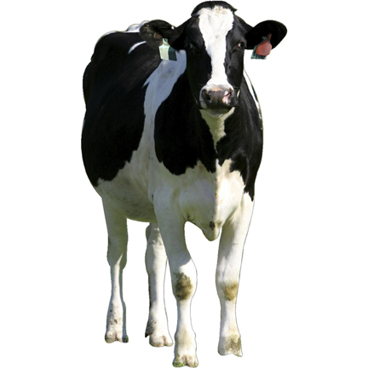

Scenario 5: Keep or Cull Ewes
- The average ewe will live for 6-8 years producing lambs each spring. Good ewes should lamb by age 2, have good body condition, history of twins or triplets preferred, and be good milk producers. “Cull” 2 of the following ewes by placing an “X” on the 2 that will go to market.

Ewe D:

2 Years old.
Had triplets, raised twins.

Ewe A:

4 years old.
Raised twins this year
Ewe B:

4 years old.
Had triplets and only fed one due to mastitis, which left one side of her udder damaged.
Ewe C:

8 years old.
Raised one lamb.
Poor body condition.
Ewe E:

2 years old, raised single lamb.
Very good body condition.

