Name: _______________________________________ Hour: __________ Date: _____________________

Plant & Soil Science
Year End Skills Test Review

STANDARD 1
Students will explain the role of FFA in agricultural education.

Describe how, when, and why FFA was organized.

- What year and wear was FFA started?

Identify key FFA historical events.

- Identify 1 major thing that happened in each year below:

  - 1917
  - 1928
  - 1930
  - 1944
  - 1950
  - 1965
  - 1969
  - 1971
  - 1984
  - 1988

Identify the mission and strategies, colors, motto, emblem and parts of the emblem, and organizational structure of FFA.

- FFA Mission:

- FFA Motto:

- Label the parts of the emblem

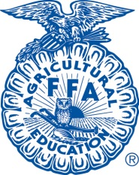

STANDARD 2
Students will explain the role of supervised agricultural experience (SAE) programs in agricultural education.

Explain the meaning and benefits of supervised agricultural experience.

- Describe 3 or more benefits of having a productive SAE

Determine the types of SAE programs

- Distinguish the differences in each of the following types of SAE’s
  - Placement

  - Entrepreneurship

  - Agriscience/Research

  - Improvement

  - Exploratory

STANDARD 3
Students will explain the history, importance, and scope of plant science.

Explain how the science of agriculture helped develop civilization, including agronomic, horticultural, and forestry plants.

- Describe how agriculture and its advancements drove the development of civilizations through time.

Identify the major innovators and milestones in the advancement of agriculture.

- Determine & describe 3 major inventions that became milestones to advance plant based agriculture.

Identify the various roles of plants in everyday life.

- List 5 ways that plants effect your everyday life

Identify agriculturally important plants, and explain their uses.

- Describe 5 major plant crops and list it’s use

Identify and describe the major areas of plant science.

- Define the following vocabulary used in Plant Science:
  - Ornamental Horticulture
  - Olericulture
  - Floriculture
  - Pomology
  - Agronomy
STANDARD 4
Students will explain soil science concepts.

Explain the importance of soil as a life-supporting layer.

- Describe how soil is crucial to sustaining life

Explain soil components.

- List some components (ingredients) that make up soil.

- What is the difference between an ORGANIC soil component and an INORGANIC soil component?

- What are examples of ORGANIC soil components?

- What are examples of INORGANIC soil components?

Describe the physical characteristics of soil and soilless media.

- Describe the 3 particle sizes soil is composed of

Describe the biological activity within soil and soilless media.

- What living organisms are found in soil? What is their purpose?

- Besides living organisms, what other biologic (live) activity takes place?

Describe the chemical properties of soil and soilless media.

- Describe what Cation Exchange Capacity (CEC) in soil is

- How can you increase the CEC in soil?

Explain the characteristics of water movement in soil and soilless media.

- Describe how the following factors effect a soil’s ability to absorb water:
  - Soil Texture
  - Slope
  - Soil Temperature
  - Plant Growth
Describe the meaning and importance of soil fertility.

- Define soil fertility

- List the 3 MACRONUTRIENTS found in soil

- Describe why water is considered a soil nutrient. (How does it effect nutrient availability?)

- List 3 MICRONUTRIENTS found in soil

- What macronutrient turns leaves green?

- What macronutrient feeds the roots and encourages cell division?

- What macronutrient develops chlorophyll and increases disease resistence?

Explain the role of organic matter, soil depth, surface slope, soil organisms, and nutrient balance in soil productivity.

- What organic substances can be added to soil to increase it’s available nutrients?

- How does the depth of topsoil affect a soil’s ability to produce quality plants?

- How does slope effect the growth of plants?

STANDARD 5
Students will describe plant anatomy and physiology concepts.

Explain systems used to classify plants.

- What is binomial nomenclature & who developed it?
- Why are scientific names of plants used instead of common names?
- What is a ‘cultivar?’
Classify plants according to life cycles, plant use, and status as monocotyledons or dicotyledons.

- Define the following plants by their life cycle:
  - Annual
  - Biennial
  - Perennial

- Label the following characteristics as monocot or dicot:
  - ___________Parallel veins in leaves
  - ___________1 cotyledon
  - ___________Netted Veins in leaves
  - ___________2 Cotyledons on leaves
  - ___________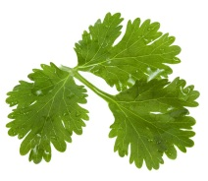
  - ___________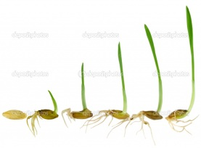
  - ___________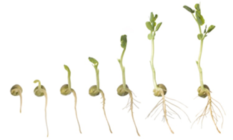

  - ___________lillies, onions, corn, grass
  - ___________trees & flowers

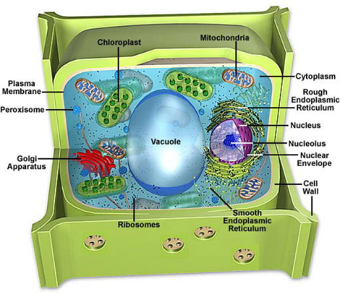
Describe the structures of a typical plant cell and their functions.

- What do plant cells have that animal cells DON’T?
- What cell organelle packages and sorts proteins?
- What cell organelle manufactures protein?
- What is the most exterior portion of the plant cell?
- What organelle controls the function of the cell?

Compare and contrast mitosis and meiosis.

- What is the difference between mitosis and meiosis?

- Where in the plant does meiosis take place?
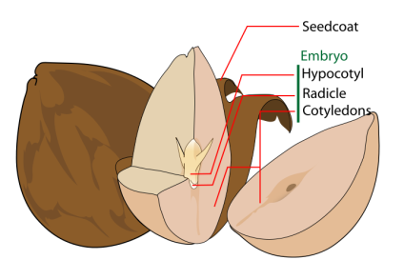

Describe the structures of a seed, the types of seeds, and the function of seeds.

- What is the purpose of the seed coat?

- Which portion of the seed will develop into the new plant?
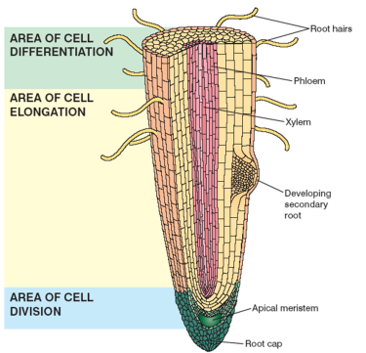
Describe the components of a root, the types of roots, and the functions of roots.

- Which portion of the root absorbs water and moisture through osmosis?

- What type of root has 1 single dominant root that tapers downward? (carrot)

- What type of root has NO primary root, but does have many secondary roots that spread through the soil?

Describe the structures of a stem, the types of stems, and the functions of stems.

- Define & describe the following modified stems
  - Rhizome

  - Tuber

  - Tendril

  - Bulb or Corm
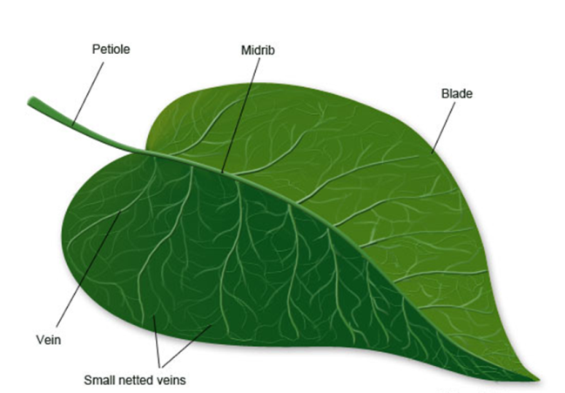
Describe the structures of a leaf, the types of leaves, and the functions of leaves.

- What is the purpose of a leaf?

- Label the following leaves as simple, compound, or whorled
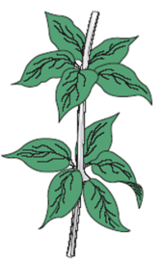
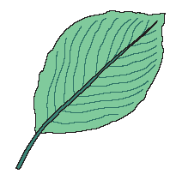
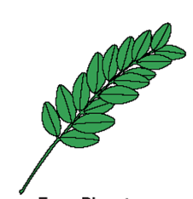

- What is a petiole?
Describe the major parts of a flower, their functions, and the types of flowers and flower forms.
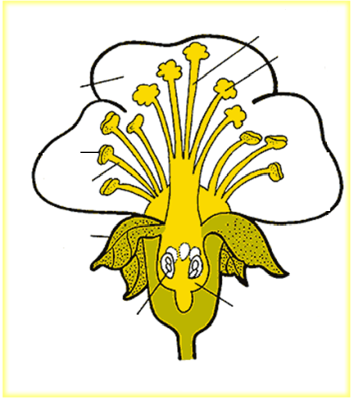
- Label the parts of a flower on the diagram to the right

- What is the difference between a complete flower and an incomplete flower?

- What is the difference between a perfect flower and an imperfect flower?

Describe the structures of fruit, the types of fruit, and the purpose of fruit.

- What fruit structure is the skin of a fruit considered?

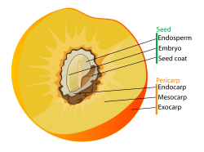
- Give an example of a fruit with a fleshy pericarp.

- Give an example of a fruit with a dry pericarp.

- What is an example of a berry fruit?

- What is an example of an aggregate fruit?

- Besides eating, what is the purpose of the fruit of a plant?

Describe the functions of water in plant growth.

- List 3 functions that water plays in plant growth

Explain plant responses to a shortage or excess of water.

- What symptoms does an OVERwatered plant show?

- What symptoms does an UNDERwatered plant show?

Explain the qualities of light that affect plant growth, including color, intensity, and duration.

- What is the difference between light color and light intensity?

- Define or describe what a “photoperiodic” plant is.

- What is the difference between a “short day” plant and a “long day” plant?

Describe the effects of temperature on plant growth.

- What is the definition of “thermoperiod?”

- What does the word “vernalization” describe in plant science?

- The United States is divided into 13 areas called _________________________________. These zones use average minimum and maximum temperatures to determine what plants can grow there.

- The temperature of different seasons provides a different stage of growth and development for a plant. Describe them:
  - Spring

  - Summer

  - Fall

  - Winter

Describe plant responses to temperature extremes.
- In extreme heat, what do plants do to regulate temperature?
Describe the effect of diseases and insects on plant growth.

- What effect do diseases and/or insects have on a growing plant?

- What is IPM? Describe it.

- Label the following as a pest or disease:

  - _________Aphids
  - _________Fungus Gnat
  - _________Leaf Miner
  - _________Mealy Bug
  - _________Spider Mite
  - _________Mosaic Virus
  - _________Black Spot
  - _________Botrytis
  - _________Iron Chlorosis
  - _________Scale

Explain the basic process of photosynthesis and its importance to life on Earth.

- What purpose does photosynthesis have to a plant?

- How does photosynthesis effect our environment?

Explain requirements necessary for photosynthesis to occur, and identify the products and byproducts of photosynthesis.
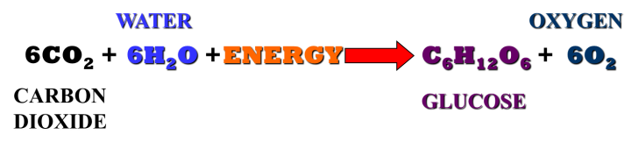
- Where does a plant get its energy? (as shown in photosynthesis equation)
- What does a plant take IN to conduct photosynthesis?
- What is a byproduct of photosynthesis?

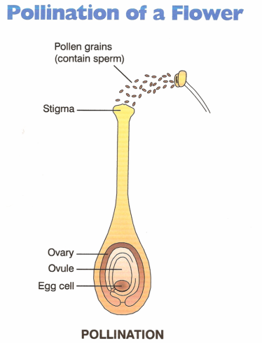
Explain cellular respiration and its importance to plant life.

- What is the difference between respiration and photosynthesis?

Compare and contrast sexual and asexual reproduction.

- What is the difference between sexual and asexual plant reproduction?

- What are 3 methods of asexual plant reproduction?

- What is the primary method of sexual plant reproduction?

Explain pollination, cross-pollination, and self-pollination of flowering plants.

- During pollination, pollen transfers from the _________________________ to the ____________________________ of the flower.

- What’s the difference between cross-pollination and self-pollination?

- If a flower is NOT pollinated, what is the result on a plant used for a food crop?
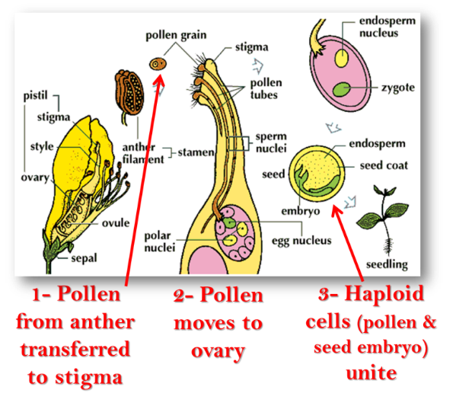

Diagram the process of plant fertilization.

- Review the fertilization process

Describe the process of seed germination & explain the conditions required for seed germination

- A seed can be stored for years. What environmental conditions trigger a seed to germinate?
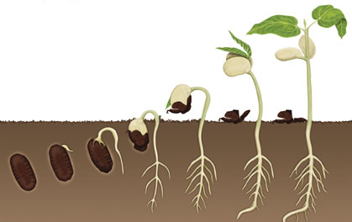

- Use the diagram below to describe each step of seed germination.

Demonstrate techniques used to propagate plants by cuttings, division, separation, and layering.

- In a couple of sentences, describe the process of the following methods of asexual propagation:

  - Cuttings:

  - Division

  - Separation

  - Layering

Describe grafting techniques.

- What is the purpose of grafting?

- List & describe 3 methods of grafting (look at Plant Propagation Unit Notes)

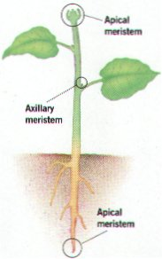
Describe the role of the apical meristem in plant growth.

- What are the 2 locations of the apical meristem?

- What role do they play in plant growth?

STANDARD 6
Students will explain principles of horticulture.

Plan and prepare a vegetable/herb garden.

- What are 3 benefits of growing your own vegetable/herb garden?

Describe the important techniques in producing tree fruits and small fruits.

- List 3 fruits that grow on trees

- List 3 vine fruits

Explain the techniques involved in producing small grain and oil crops.

- List 3 examples of oil crops

- List 3 examples of small grain products

- Are oil and small grain crops used for human consumption or animal feed?
Discuss the importance of hay and forage production to the overall food system.

- What are some common forage plants used to produce hay?

- How does the production of hay and forage effect our human food system?

Describe lawn establishment and care & describe the important techniques of landscape maintenance.

- Describe the purpose of the following lawn maintenance procedures:
  - Fertilizing

  - Weed Control

  - Aerating

Plan and prepare a flower garden.

- Using your knowledge of plants, list 3 principles you should consider and follow when planning a flower garden.

Describe the elements of growing plants indoors.
- List 5 common houseplants

