Name:_______________________________ Hour:___________ Date:__________________
Animal Systems Test Review
Skeletal System
-Function & Purpose:
-Things that make up the system:
-Define cartilage:
-List the types of bones and give an example of each:
1.
2.
3.
4.

Muscular System
-Function & Purpose:
-Types of Muscles & an example of each:
1.
2.
3.
-Define Tendons & Ligaments:
-Define sarcomere:
-What happens during a muscle contraction?

Respiratory System
-Function & Purpose:
-Things that make up the system:
-What is the name of a Rooster’s voice box?

Circulatory System
-Function & Purpose:
-Things that make up the system:
-Chambers of the Heart in Order:

Nervous System
-Function & Purpose:
-Things that make up the system:

Excretory System
-Function & Purpose:
-Things that make up the system:
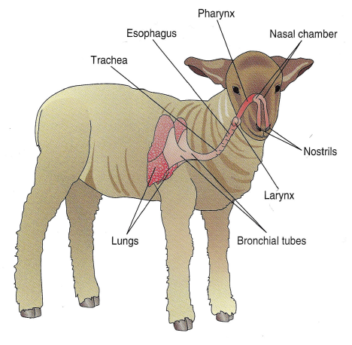
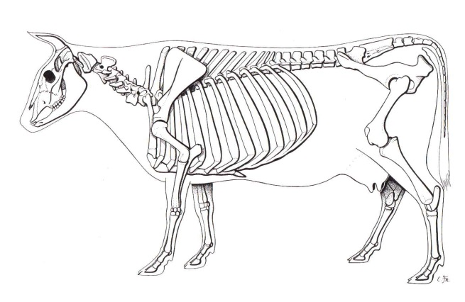
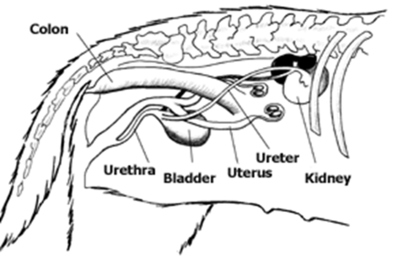
LABEL THE SYSTEM BELOW THAT IS PICTURED
