Name___________________________________ Period___________ Date__________________

Reproductive Technologies
Mouse Cloning Lab
Directions:
-Go to the website: http://learn.genetics.utah.edu/content/tech/cloning/clickandclone/
-Follow the “Click and Clone” directions to clone Mimi the mouse
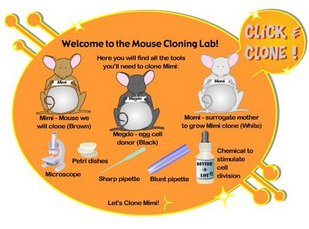
-Answer the questions as you complete the assignment

- Step #1:

1a-Which mouse provides the somatic cell?

1b- Which mouse provides the egg cell?

- Step #2:

- Step #3

3a: The nucleus from the ______________cell is transferred to the _________________

- Step #4:

4a- What was the purpose of waiting before beginning step #5?

4b- What is the name of the “ball” or 16 cells that is now in the petri dish?

- Step #5:

- Step #6:

- Who is genetically the mother and father of the newly cloned mouse pup?

Directions: Go to the websites listed below and answer the questions below.

Estrous Synchronization- http://beef.osu.edu/library/estrusny.html

1- What percentage of beef cattle are bred using A.I. in the United States? Why are there so few?

2- List two of the Advantages of Successful Estrous Synchronization.

3- List the requirements for Estrus Synchronization.

4- Based on what you've read and learned in class what are some of the advantages and disadvantages of Estrus Synchronization?

Artificial Insemination- http://extension.missouri.edu/publications/DisplayPub.aspx?P=G2312

1- Based on this article and what you've learned in class what are some of the advantages and disadvantages of Artificial Insemination in swine?

2- Why is A.I. easier and less time consuming in Swine than any other species?

Embryo Transfer- http://www.reprospecialty.com/information.html

1- What are the two groups that candidates for Embryo Transfer fall into?

2-Describe the process of collecting embryos from a donor female.

3- What does the Embryologist evaluate the collected embryos for?

