Name__________________________________________ Period______ Date____________________

Veterinary Medications
Common Take Home Meds
You should be familiar with the names of common medications vets prescribe. Though you will never prescribe medication, you should be familiar with the name of common medications and what they are used for. Use the classroom set of Patient Information Sheets and answer the question(s) in each box. The questions represent common inquiries a pet owner may ask you in the vet clinic or on the phone.

Antibiotics:
Amoxicillin  - “I have some leftover amoxicillin from when my cat had a UTI, can I use it on my rabbit?”  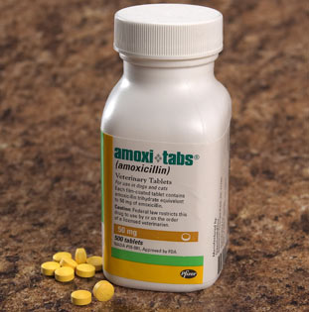  - “My dog’s infection seemed cleared up after only 5 days, should I continue the last 5 days of pills?” | Baytril  1-“I have some leftover baytril for my guinea pig. My rabbit is in need of some antibiotics. Is baytril safe for rabbits?”  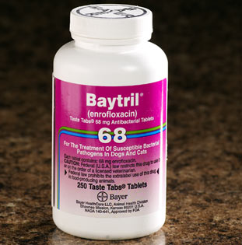  2- “Baytril is too expensive, is there a generic brand of this antibiotic I can buy instead?”
Cephalexin  - “Are there any special instructions for storing the liquid Cephalexin?  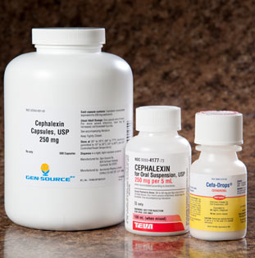  - “I came home with 2 medications. One was cephalexin and the other was prednisone. Which one was to treat the UTI? | Doxycycline  - “My dog vomits every time I give the pills. What should I do?”  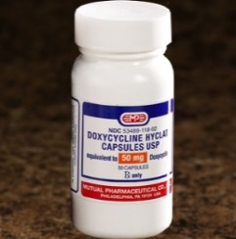  - “My dog is diabetic and has daily insulin shots, could there be any drug interactions?”
Metronidazole
- “Should I do anything specific with the liquid form of this medication before giving it to my pet?”

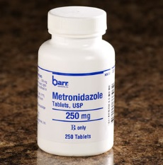

- “What one-celled parasite can metronidazole treat?”

Allergy/Antihistamine:
Atopica  - “Can I put the powder from the capsule on my dog’s food?”  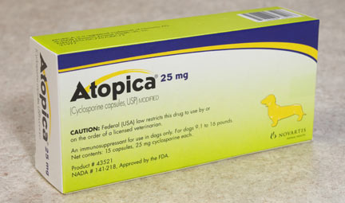  - “I was out of town and missed a dose, what should I do?” | Prednisone  - “I just started my dog on prednisone to control allergies, are there any side effects?  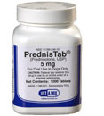  - “I just bred my female yorkie who takes pred every 3 days to control allergies. Can I give it to her while she’s pregnant?

Anti-inflammatory/Pain:
Deramaxx  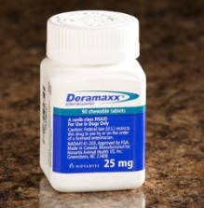  - I have some leftover deramaxx that was used to control pain in my dog. My cat is showing signs of arthritis, can I use the leftovers?  - I need an arthritis medication for my dog, but he had an allergic reaction to Metacam, do you think Deramaxx will work? | Metacam  - My dog started vomiting when we started giving the Metacam, what would cause this?  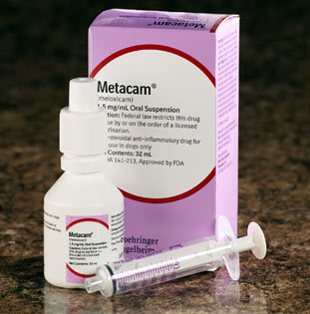  - What class of drug is Metacam?
Rimadyl  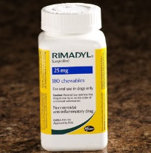  - My dog just had surgery on his hip. You sent me home with 2 medications. One is Rimadyl and the other is Amoxi Tabs. Which one is for pain? Can I give them at the same time?  - My dog has been on Rimadyl for 2 years now to control her arthritis pain. She has been sick and isn’t eating. Is it sill safe to give Rimadyl? Why? | Phenylbutazone (Bute)  - How should the injectable form be administered?  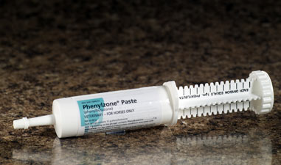  - “I have a horse show this weekend, does this medication have a withdrawl period so that my horse doesn’t test positive on a blood test? How long?
Ears:
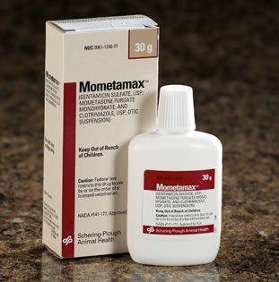
Mometamax or Otomax
1-“What does this treat?”

2-“Should I do anything before I apply the medicine?”

Panolog  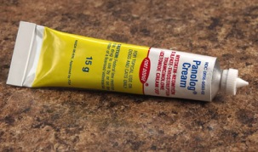  - “My dog has a hot spot on his shoulder, should I do anything specific before applying panolog?”  - “Other than bacteria, what type of infections does panolog treat?” | Tresaderm  - “Do I just put the drops in the ears? Is there anything else I should do?  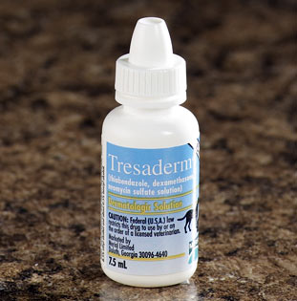  - “Are there any side effects associated with these ear drops?”
Eyes:
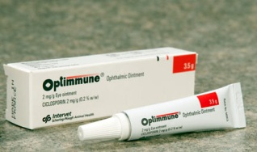  Optimune  - What condition does this ointment treat?  - I have 2 different eye ointments. Do I just give one right after the other? | Gentocin Ophthalmic Solution  - “My cat’s eyes are full of thick yellow discharge, should I do anything before applying the eye drop?”  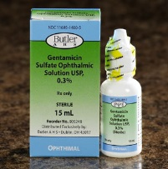  - “How quickly can I expect to see improvement?”
Seizures/Epilepsy:
Potassium Bromide  - My family is going out of the town for the day. What is the danger in missing 1 dose?  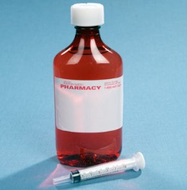  - If you are using the capsule form of this medication, what should be done to be sure it doesn’t get lodged in the esophagus? | Phenobarbitol  - Are there any behavioral changes when dogs are on phenobarbital?  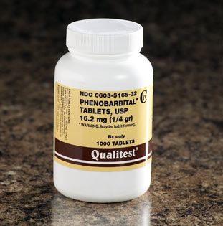  - “I was told that I have to get a blood test for my dog before I can refill his phenobarbital prescription. What is it and why is it required?

Heart:
Enalapril  - “ My dog is in the early stages of heart failure, what does this medication do?”  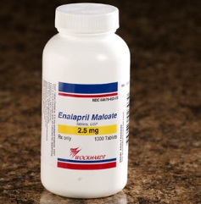  - “How long til I will see results? How long can I expect my dog to be on this medication?” | Lasix  - “I just started my cat on Lasix, the last 2 days he has been walking funny and with a head tilt. Could this be related to the medication?  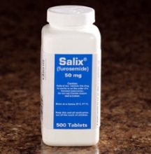  - My dog also takes Deramaxx for arthritis, could there be a problem with these 2 medications being taken at the same time?

Thyroid:
Soloxine  - What condition does soloxine treat?  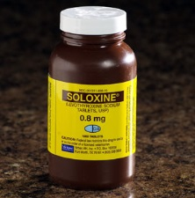  - My dog seems to be drinking a ton of water, urinating a lot and seems hyper active. Could there be a problem with his soloxine dose? | Methimazole  - What does this medication treat?  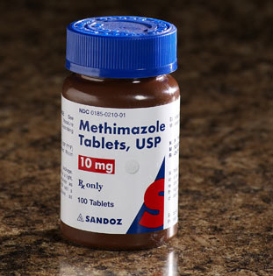  - Are there any human safety precautions that should be taken by the owner administering this medication to a cat?

Respiratory System:
Temaril P
- What symptoms does this medication relieve?

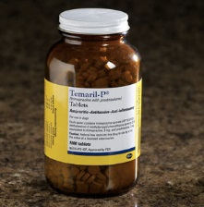
- Should this medication be given with food? Why?

Urinary System:
Diethylstilbestrol (DES)  - What does this medication treat?  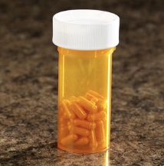  - Are there any cautions I should take when giving my dog DES? | Proin  - What does this medication treat?  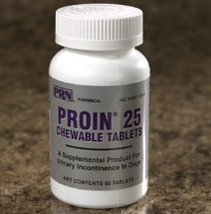  - What are the signs of an allergic reaction to this medication?

Reproductive System:
Regu-Mate
- Are there any special instructions for human safety with this medication?

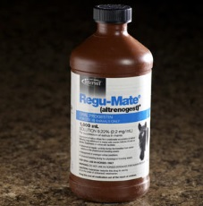
- What should you do if this medication was ingested by a child?

- What is the purpose of this medication?

